Stage pipeline creation

Step 1. <build>
<finalName>zenpolicies-service-talent</finalName>
<plugins>
<plugin>
<groupId>org.springframework.boot</groupId>
<artifactId>spring-boot-maven-plugin</artifactId>
<configuration>
<mainClass>com.zensar.zenhelp.ZenpoliciesServiceZentalentApplication</mainClass>
<addResources>true</addResources>
</configuration>
</plugin>
</plugins>
</build>

final name and main class tag should be there.

Note:
Add docker file
having

FROM jdk-1_8_201:base
ADD target/exit-service-talent.jar /exit-service-talent.jar
ENTRYPOINT ["/usr/bin/java"]
CMD ["-jar", "/exit-service-talent.jar"]
EXPOSE 67

Step 2.
Jenkins ----> New Item ---->make folder ZenFinance_ZenTalent
make

Step 3.
Click on New Item ----> choose freeStyle project -----> folder name shuld be like zenfinance

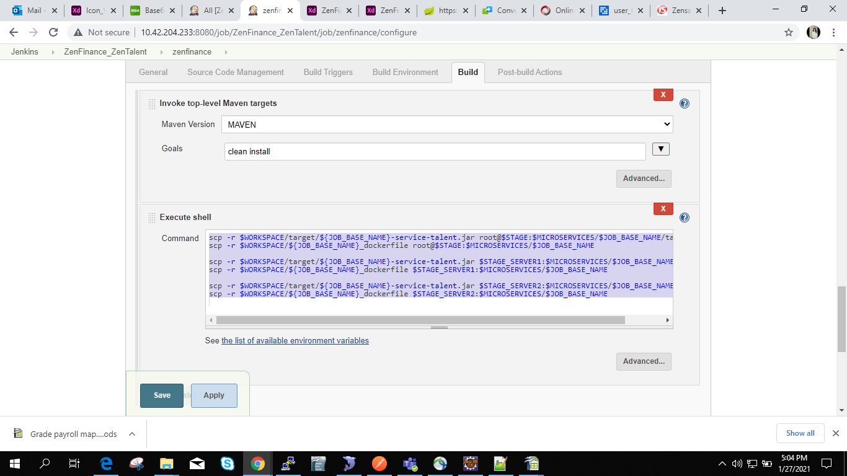

scp -r $WORKSPACE/target/${JOB_BASE_NAME}-service-talent.jar root@$STAGE:$MICROSERVICES/$JOB_BASE_NAME/target/
scp -r $WORKSPACE/${JOB_BASE_NAME}_dockerfile root@$STAGE:$MICROSERVICES/$JOB_BASE_NAME

scp -r $WORKSPACE/target/${JOB_BASE_NAME}-service-talent.jar $STAGE_SERVER1:$MICROSERVICES/$JOB_BASE_NAME/target/
scp -r $WORKSPACE/${JOB_BASE_NAME}_dockerfile $STAGE_SERVER1:$MICROSERVICES/$JOB_BASE_NAME

scp -r $WORKSPACE/target/${JOB_BASE_NAME}-service-talent.jar $STAGE_SERVER2:$MICROSERVICES/$JOB_BASE_NAME/target/
scp -r $WORKSPACE/${JOB_BASE_NAME}_dockerfile $STAGE_SERVER2:$MICROSERVICES/$JOB_BASE_NAME

Step 4.
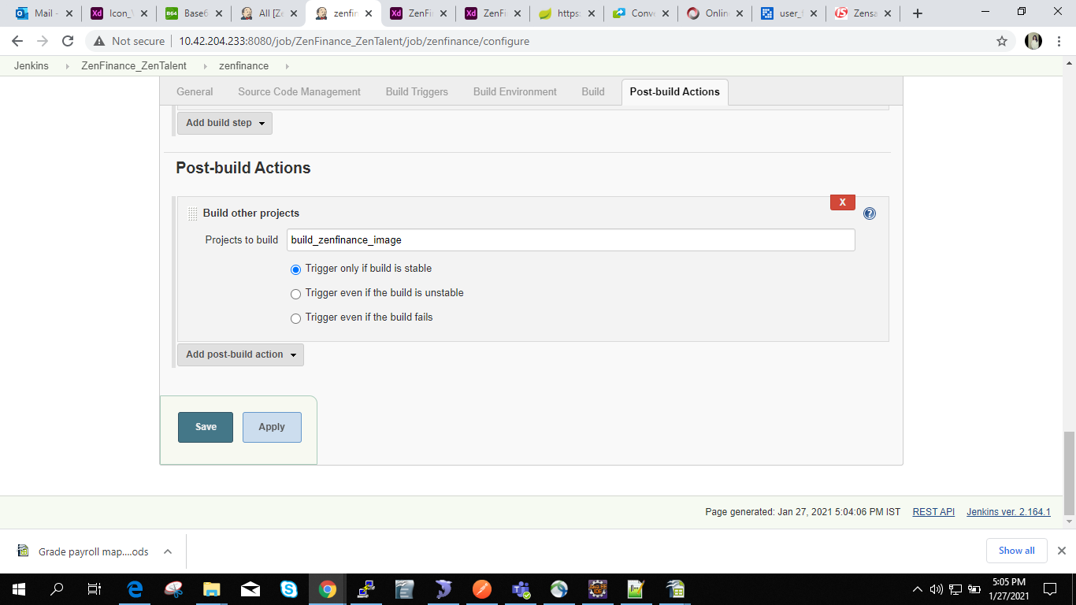

Step 5.
Click on New Item -----> make folder choosing freestyle project name like build_zenfinance_image

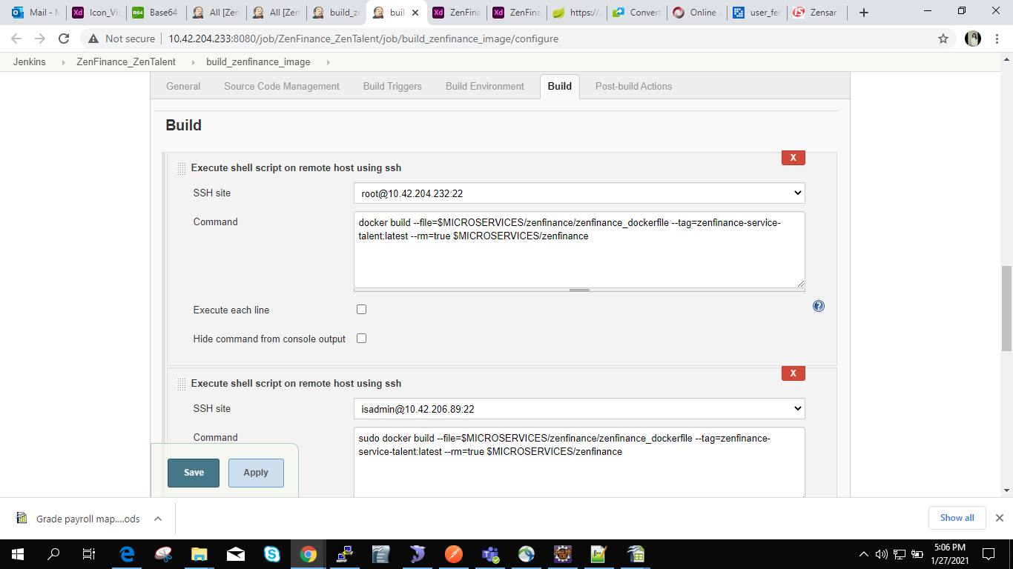

then
paste
docker build --file=$MICROSERVICES/zenfinance/zenfinance_dockerfile --tag=zenfinance-service-talent:latest --rm=true $MICROSERVICES/zenfinance

isadmin@10.42.206.89:22
sudo docker build --file=$MICROSERVICES/zenfinance/zenfinance_dockerfile --tag=zenfinance-service-talent:latest --rm=true $MICROSERVICES/zenfinance

isadmin@10.42.206.90:22

sudo docker build --file=$MICROSERVICES/zenfinance/zenfinance_dockerfile --tag=zenfinance-service-talent:latest --rm=true $MICROSERVICES/zenfinance

Then Post build action
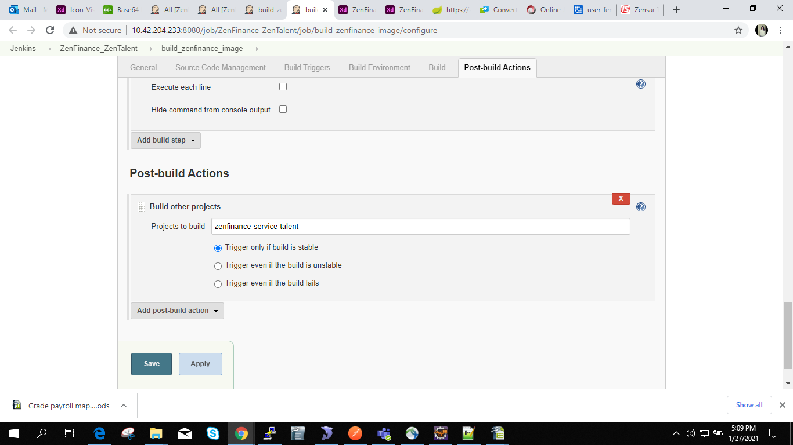

Step 6.

New Item -----> freeStyleProject folder name should be like zenfinance-service-talent

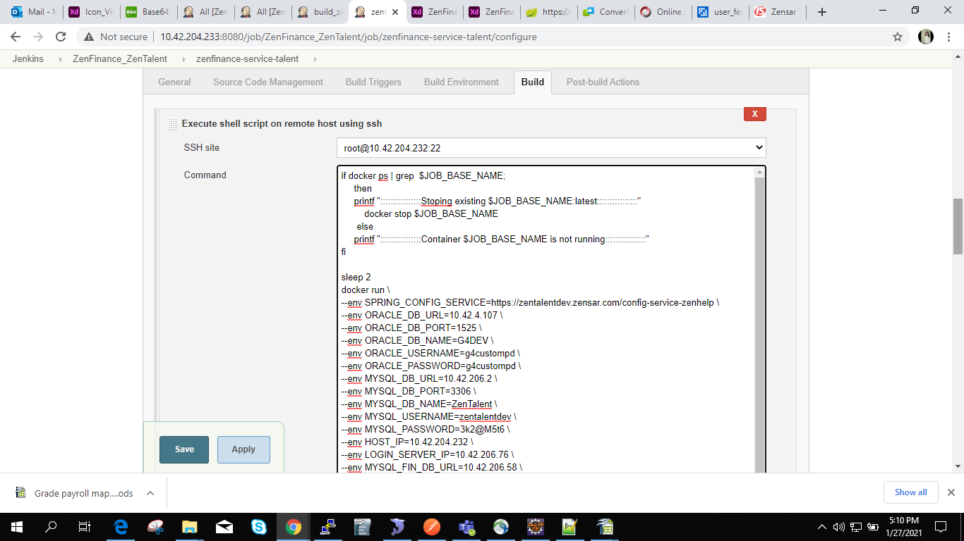

Set Environment variables for all servers

if docker ps | grep $JOB_BASE_NAME;
then
printf "::::::::::::::::Stoping existing $JOB_BASE_NAME:latest::::::::::::::::"
docker stop $JOB_BASE_NAME
else
printf "::::::::::::::::Container $JOB_BASE_NAME is not running::::::::::::::::"
fi

sleep 2
docker run \
--env SPRING_CONFIG_SERVICE=https://zentalentdev.zensar.com/config-service-zenhelp \
--env ORACLE_DB_URL=10.42.4.107 \
--env ORACLE_DB_PORT=1525 \
--env ORACLE_DB_NAME=G4DEV \
--env ORACLE_USERNAME=g4custompd \
--env ORACLE_PASSWORD=g4custompd \
--env MYSQL_DB_URL=10.42.206.2 \
--env MYSQL_DB_PORT=3306 \
--env MYSQL_DB_NAME=ZenTalent \
--env MYSQL_USERNAME=zentalentdev \
--env MYSQL_PASSWORD=3k2@M5t6 \
--env HOST_IP=10.42.204.232 \
--env LOGIN_SERVER_IP=10.42.206.76 \
--env MYSQL_FIN_DB_URL=10.42.206.58 \
--env MYSQL_FIN_DB_PORT=3306 \
--env MYSQL_FIN_DB_NAME=ZenCFO_DEV \
--env MYSQL_FIN_USERNAME=am46186 \
--env MYSQL_FIN_PASSWORD=mX827#Tx \
-d -e "TZ=Asia/Kolkata" -v /upload:/upload --rm=true --name=$JOB_BASE_NAME --publish=69:69 $JOB_BASE_NAME:latest

printf ":::::::::::::::::::::::::check log file $DOCKER_LOGS for $JOB_BASE_NAME::::::::::::::::::::::::::::"

docker logs $JOB_BASE_NAME --follow >> $DOCKER_LOGS/$JOB_BASE_NAME.log 2>&1 &

For making pipeline
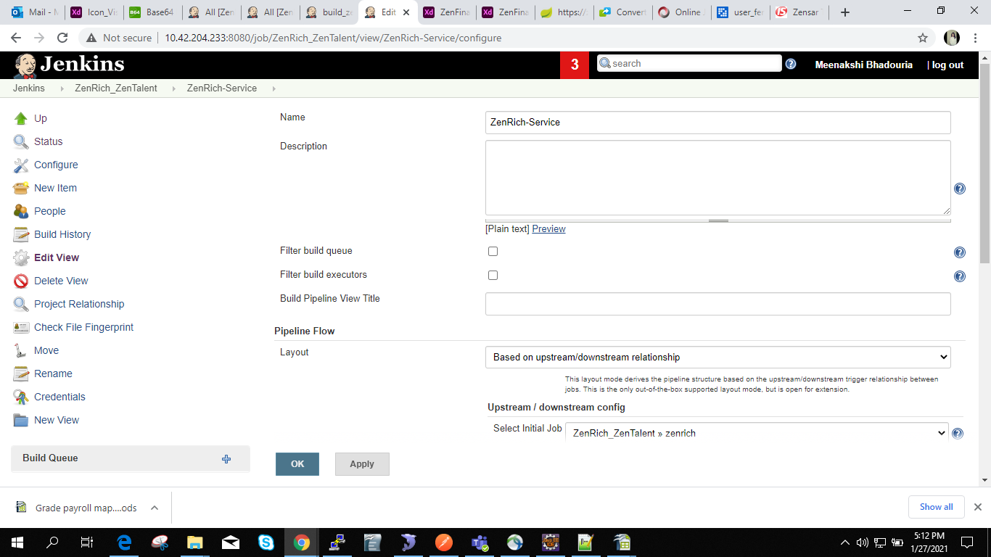

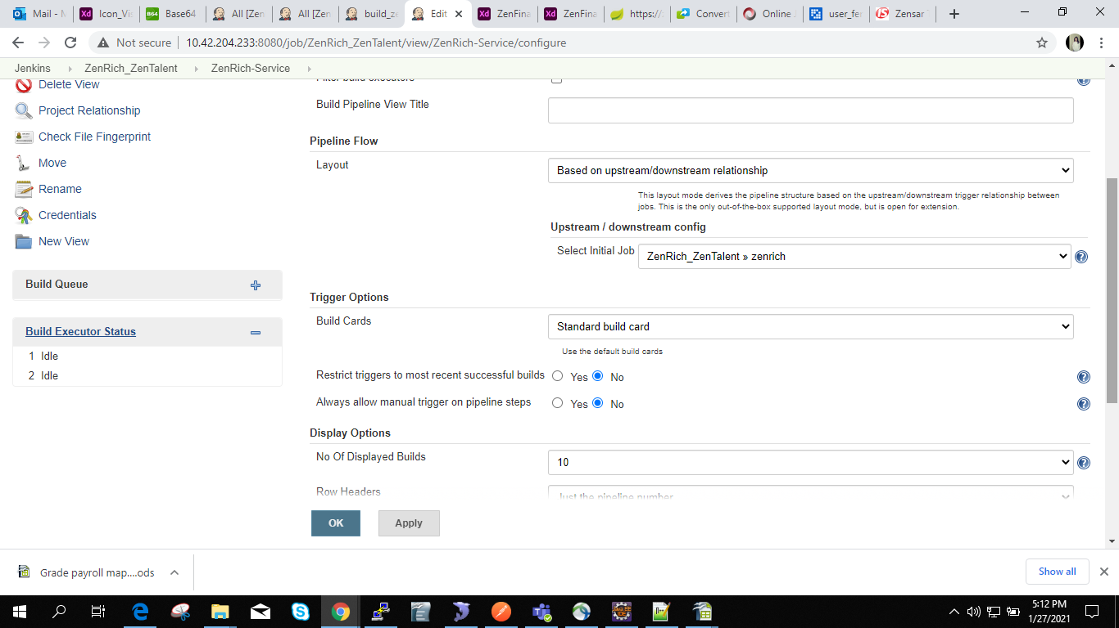

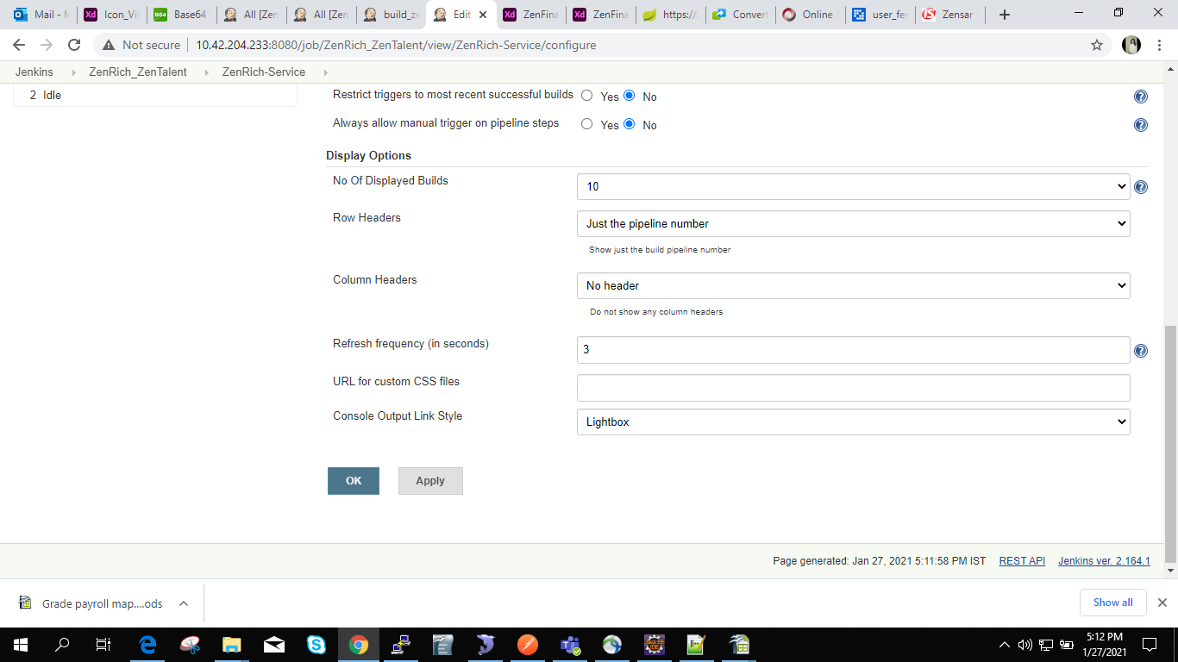

NOTE: /usr/local/microservices/ZenHelp at this location make folder like zenrich / zenfinance

